UML DIAGRAM
  - Use Case Diagram
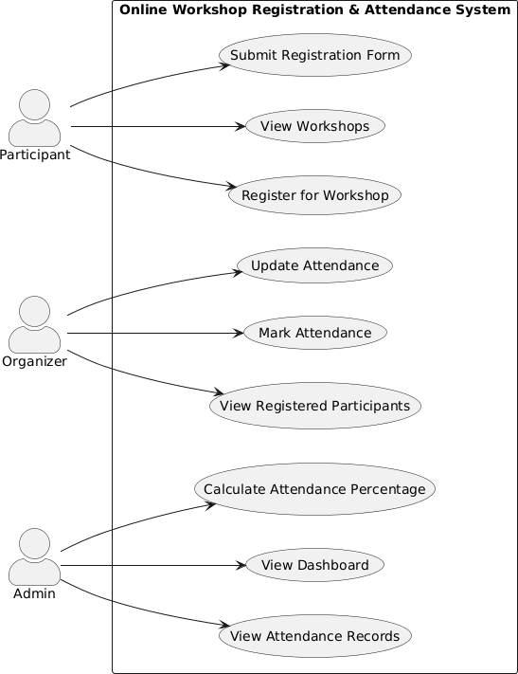

Figure 3.1 Use Case Diagram

  - Class Diagram
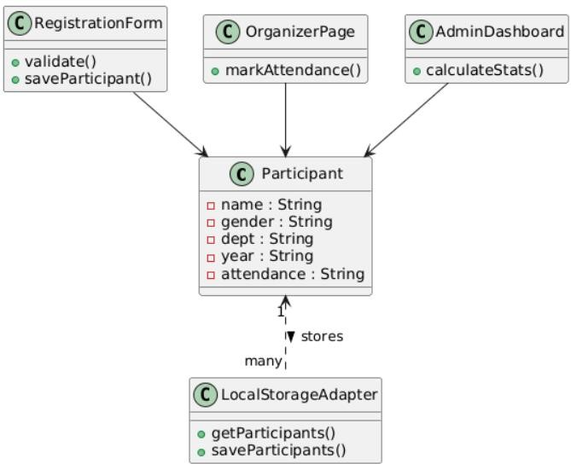

Figure 3.2 Class Diagram

  - Activity Diagram
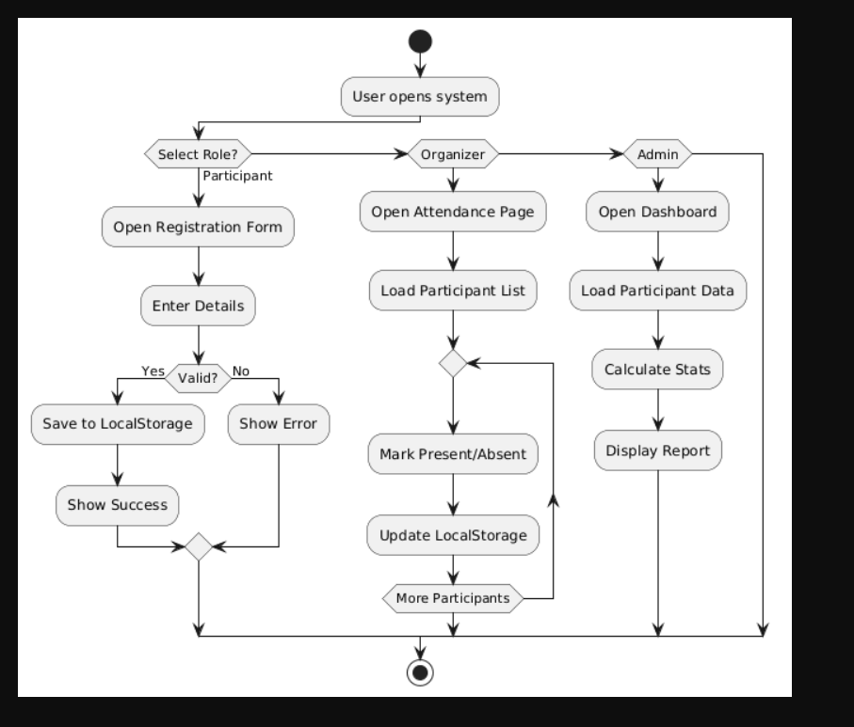

Figure 3.3 Activity Diagram

  - Sequence Diagram
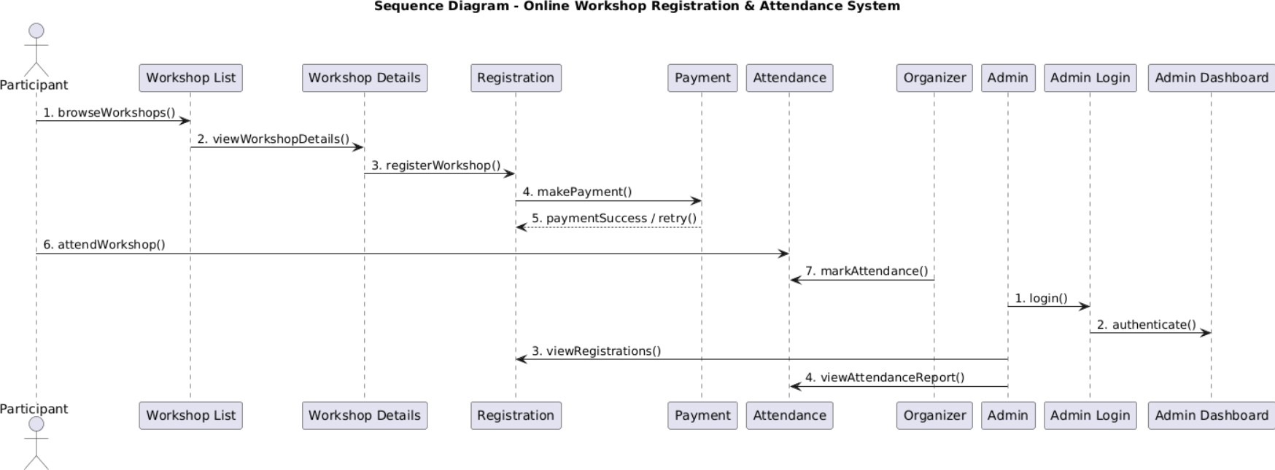

Figure 3.4 Sequence Diagram

  - State Machine Diagram
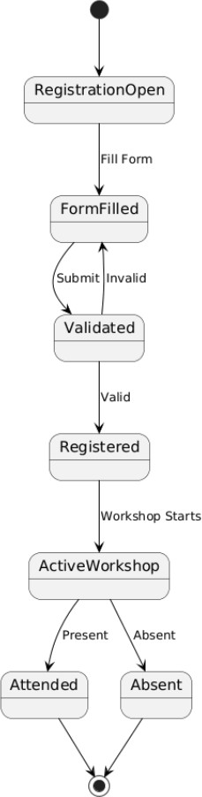

Figure 3.5 State Machine Diagram

  - Component Diagram
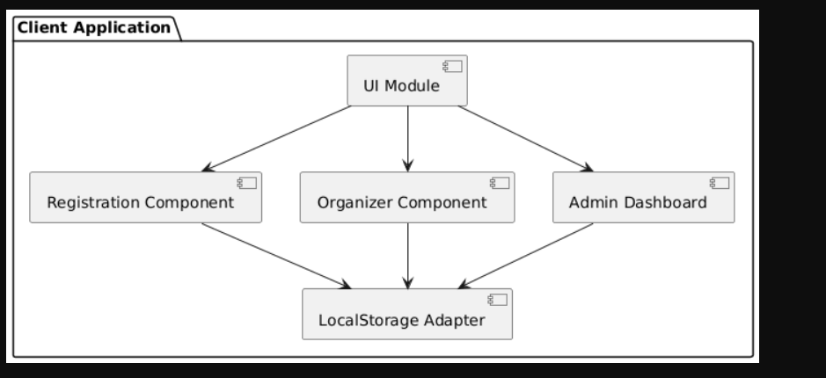
Figure 3.6 Component Diagram

  - Deployment Diagram
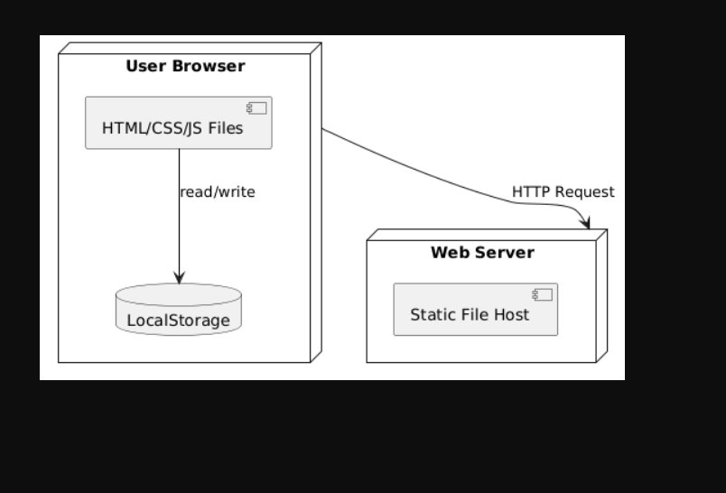
Figure 3.6 Component Diagram

  - Package Diagram
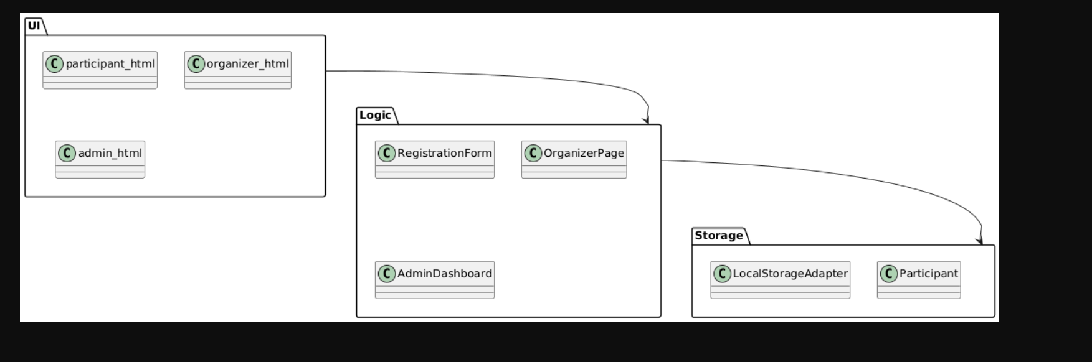
Figure 3.8 Package Diagram

  - Collaboration Diagram
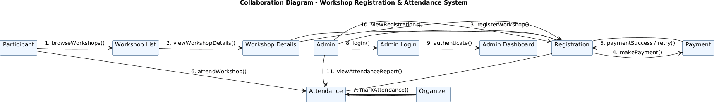

Figure 3.9 Collaboration Diagram

